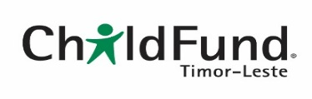**Monitoring, Evaluation and Learning (MEL) Manager**

**PURPOSE OF THE POSITION**

As the MEL Manager you ensure ChildFund Timor-Leste’s programs operate under the organization’s Monitoring, Evaluation and Learning Framework to a high standard and in a timely manner. Fundamentally this entails building the capacity of program staff to understand, and apply, the Monitoring, Evaluation and Learning Framework. You work closely with the Program Manager and support all in-country departments. You will be part of the broader ChildFund Australia offices MEL team in 6 different countries and strongly collaborate with the MEL team in the ChildFund Australia office in Sydney.

**SKILLS**

Strong leader, supporting others in achieving their & the organisation goals

Change champion

Up-to-date with the latest trends and best practices in the education sector and measurement

Creative thinker and motivator, energetic, with an entrepreneurial spirit

Combines intellectual curiosity with analytical skills

**QUALIFICATIONS & EXPERIENCE**

* Tertiary qualification in a relevant discipline; postgraduate qualifications in M&E and/or international development studies would be an advantage
* 5 years’ experience at project/program level in an INGO involved in community development activities
* Sound project management and implementation skills
* Experience in adult education and/or training, designing and conducting workshops and trainings
* Minimum of 3-year experience in monitoring, evaluation and quantitative data gathering and analysis, including establishing M&E systems
* Significant experience in writing high quality reports and providing presentations
* Proficiency with relevant computer software (e.g. Excel, SPSS, EPI Info)
* Proficiency in written and spoken English.

*Remain alert and responsive to any child safeguarding risks, acquire relevant knowledge and skills which will enable you to promote strong safeguarding practices, understand the child* safeguarding policy and procedures, and conduct yourself in a manner consistent with the ChildSafeguarding Policy.”

**KEY DUTIES**

* Implement our Monitoring, Evaluation and Learning Framework based on the programming model in country including creating and setting up supporting systems.
* Develop timely and high quality survey reports and statement of impact and contribute to reviews and planning.
* Compile qualitative case studies and facilitate reflection sessions
* Support program staff in all stages of the project cycle including development of case studies
* Support MEL capacity building of partners (including community members) and staff, facilitate discussions to analyse and reflect on their practice on basis of MEL data and surveys.
* Develop MEL work plans in consultation with Program Manager for dissemination to all senior management team members.
* Maintain in-country records of MEL activities and develop benchmarks (e.g. for Evaluation reports) and reference (aggregated Outputs data and Case Studies).
* Provide advice, materials and/or training on development effectiveness to staff.
* Participate in regular MEL team meetings with other countries, contribute to ongoing, critical analysis of ChildFund practice at country and whole of agency level (including research activities).
* Maintain contact with other NGOs to ensure mutual awareness of activities and projects; and network with government officials and other agencies on relevant issues.

**CHILDFUND AUSTRALIA’S CORE COMPETENCIES**

Commitment to ChildFund Australia’s mission and vision, as well as our values: teamwork; effective communication; accountability and integrity; adaptability and flexibility.

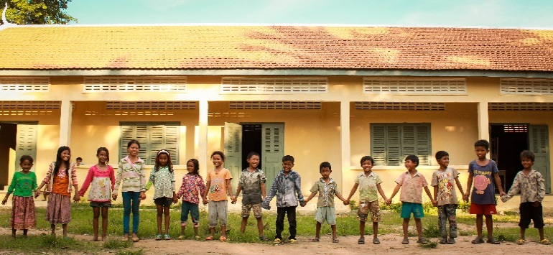

**HOW TO APPLY**

**Department:** Program

**Location:** ChildFund Timor-Leste, Rua do Loriko Colmera Dili

**Employment:** Full-time, initial two-year employment agreement, with option to extend upon mutual agreement.

**Reports to:** Head of Programs

**Other Information:** Frequent travel to project locations in Liquica, Bobonaro and Covalima and some international travel required

A working with Children Check and a Criminal History Check are required to be undertaken for this position

Please submit a cover letter and CV in English, and 3 traceable referees with contact details by emailto **fsantos@childfund.org.au** or by hand delivery, application **closes February 28, 2019.**

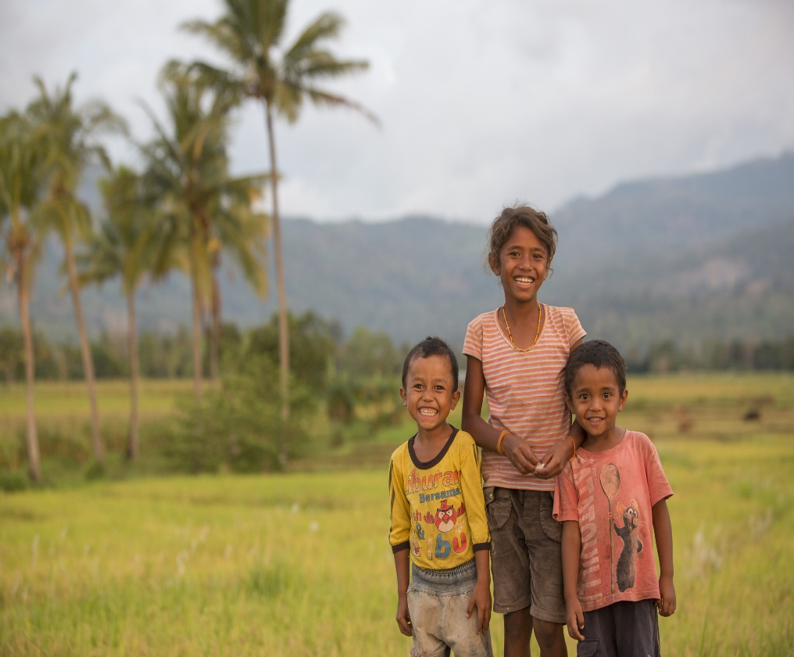

**ORGANISATIONAL CONTEXT**

**ChildFund Timor-Leste** is a representative office of ChildFund Australia. ChildFund Australia is an international development agency that works in partnership with children and their communities to create lasting and meaningful change by supporting long-term community development and promoting children’s rights.

ChildFund Australia directly implements child-focused development programs in six countries—Vietnam, Papua New Guinea, Laos, Cambodia, Myanmar, and Timor-Leste—and is responsible for projects delivered by partner organisations in the Pacific, Kenya, Uganda, Zambia, Ethiopia, Sri Lanka, the Philippines, and Indonesia. ChildFund Australia is a member of ChildFund Alliance – a global network of 11 organisations which assists more than 14 million children and families in 63 countries. ChildFund Australia is a registered charity, a member of the Australian Council for International Development, and fully accredited by the Department of Foreign Affairs and Trade, which manages the Australian Government’s overseas aid program.

ChildFund Timor-Leste is the representative office of ChildFund Australia - an independent and non-religious international developing organisation that works to reduce poverty for children in the developing world. ChildFund Australia’s goals in Timor-Leste are to achieve and demonstrate effectiveness and accountability in its program activities and add value to the efforts of its partners through quality development programs that are respectful, responsive, and effective in helping children in poverty, their families, and communities.

**HOW WE VALUE YOUR CONTRIBUTION**

**OUR VISION:** A global community, free from poverty, where children are protected and have the opportunity to reach their full potential.

**OUR MISSION:** We work in partnership with children and their communities to create lasting and meaningful change by supporting long-term community development and

promoting children’s

rights.

**Learning and Development**

Our approach to learning and development will enable you to have the information, skills, and knowledge needed to do your job and to grow in your position. We build the capacity of our people and support you with on-the-job experience, coaching and formal training.

**Space for other benefits**

Child Fund will cover Health costs for all national employees and their immediate family members, Child Fund will pay the contribution of social security to employee and provide payment in December of each year of a Thirteenth month salary to the employees.

**Remuneration Package**

We aim to provide an overall remuneration package that is attractive and fair. Our remuneration framework ensures that we align to employment conditions and laws, and we benchmark against the local market to ensure we offer competitive employment conditions that are appropriate to our sector.

**Leave**

You will have access to 15 days of paid annual leave. You are also entitled to annual leave paid, maternity leave, parental leave.

**At ChildFund Australia you will be contributing to every child being able to say: “I am safe. I am educated. I am heard. I have a future.”**

**.**