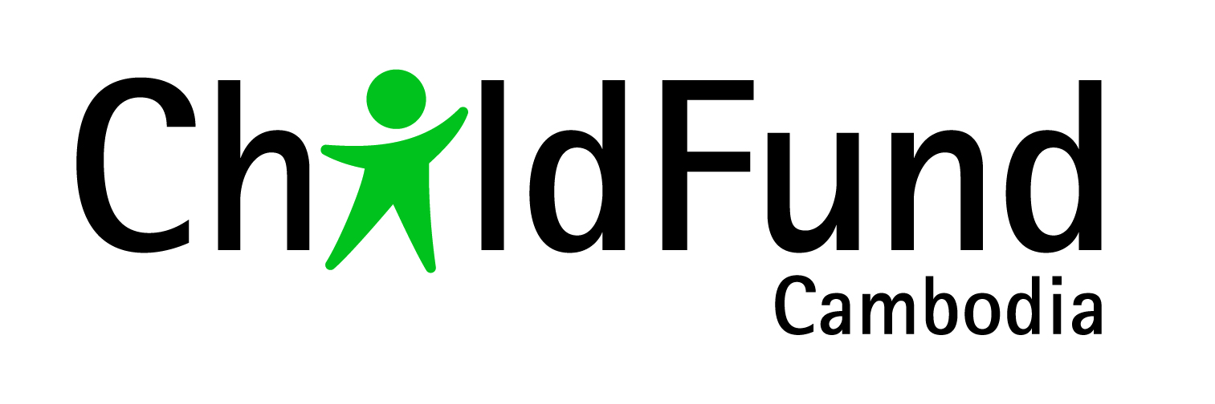
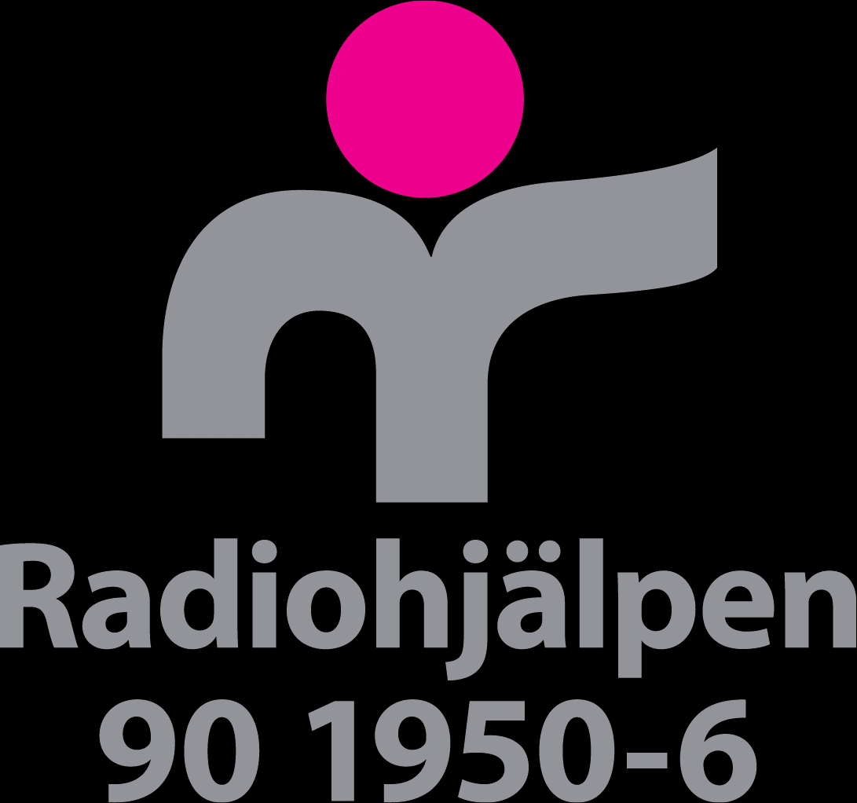
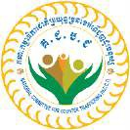

Term of Reference

A STUDY ON CHILD TRAFFICKING IN CAMBODIA
(February 15TH 2019)

- INTRODUCTION

ChildFund Cambodia is the representative office of ChildFund Australia – an independent and non‐religious international development organisation that works to reduce poverty for children in developing communities.

ChildFund Australia is a member of the ChildFund Alliance – a global network of 11 organisations which assists more than 14 million children and their families in over 60 countries. ChildFund Australia is a registered charity, a member of the Australian Council for International Development, and fully accredited by the Department of Foreign Affairs and Trade which manages the Australian Government’s overseas aid program.

ChildFund began working in Cambodia in 2007, and works in partnership with children, their communities and local institutions to create lasting change, respond to humanitarian emergencies and promote children’s rights. Projects are implemented in the rural provinces of Svay Rieng, Kratie, Battambang, as well as urban Phnom Penh, focused on improving living standards for excluded or marginalised communities.

With a focus on child protection and resilience, quality education, sustainable livelihoods, improved local governance, child nutrition, water and sanitation, and youth empowerment, ChildFund Cambodia is also working to improve early grade reading performance through technology interventions, and strengthen national community-based child protection mechanisms. ChildFund Cambodia implements its programs in collaboration with local civil society organisations, and in partnership with the relevant ministries and government departments.

II. PROJECT BACKGROUND AND CONTEXT

The pilot project “Child Friendly Communities against Unsafe Child Migration and Child Trafficking in selected 2 Communes of Romeas Heak district, Svay Rieng province, Cambodia” is funded by Radiohjalpen through Barnfonden, in partnership with CCPCR and also cooperated with the National Committee for Countering Trafficking in Persons (NCCT).
The project proposes in order to create child friendly communities, with increased responsiveness against child exposure, and ensures all children are protected from unsafe child migration and child trafficking, including commercial sexual trafficking. The project will be implemented in 16 villages in two communes in Romeas Heak district, Svay Rieng Province, and benefit the most marginalized children and youth, living in rural locations, where access to public services and information related to unsafe migration and trafficking is limited. It is an 18 months project starting from July 1st 2018 to June 30th 2020. The project aims to strengthen existing structures, in order to contribute to address the root causes of unsafe child migration, child trafficking and commercial sexual trafficking.

The ultimate goal of this project is:

“To create child friendly communities, with increased responsiveness against child exposure, and ensures all children are protected from unsafe child migration and child trafficking, including commercial sexual trafficking.”

This goal will be achieved by the following specific objectives:

- The capacity of existing local structures (formal and informal) on child migration and child trafficking strengthened in two communes in Romeas Heak district by June 2020.
- Increased knowledge on and responsiveness to unsafe child migration and child trafficking among community members, including children and youth, in the target area by June 2020.
- By June 2020 a functional referral system is established in two communes in Romeas Heak district, to prevent and respond to cases of unsafe migration and child trafficking.

The project will work with the existing mechanisms at the national and sub-national level such as provincial, district and commune level including commune council for women and children (CCWC), commune police, provincial department of social affairs and specialized local partner(s) in order to prevent and respond to unsafe child migration and trafficking in their community.

Cambodia, a country is one of the youngest in South-East Asia. According to the latest 2017 UN Population Division statistics, the total population increased from 4.4 million in 1950, to about 16 million in 2017 and this is projected to increase to 18.8 million by 2030. In 2017, 31 per cent of the 16 million population were aged 0-14 years and one fifth aged between 15-24 years. Cambodia has achieved remarkable development progress in a comparatively short period and the country is well-poised in the post-2015 era of the SDGs. Children (persons under the age of eighteen) represent around one third of the population and many of them, driven by poverty, engage in child labour, including sexual exploitation and trafficking and especially online child sexual exploitation.

Cambodia is a source, transit and destination country for children victims of trafficking. Trafficking for sexual exploitation occurs primarily from Cambodia to Thailand and Vietnam, from Vietnam to Cambodia, where children are exploited in brothels, beer gardens, massage parlours, karaoke and other venues. Including domestic work and unauthorized commercial activities.
To fight the commercial sexual exploitation of children (CSEC), the Government of Cambodia has ratified the Convention on the Rights of the Child (CRC) and its Optional Protocol on the Sale of Children, Child Prostitution and Child Pornography (OPSC), as well as the ILO Convention on the Worst Forms of Child Labour. At the national level, it has enacted the Law on Suppression of Human Trafficking and Sexual Exploitation of 2008 (TIPSE Law). The Law provides some comprehensive sets of definitions and penalties regarding the sexual exploitation of children in prostitution and the trafficking of children. It is complemented by the Cambodian Criminal Code of 2010. Cambodia is a member of the Association of Southeast Asian Nations (ASEAN), a regional mechanism particularly active regarding the issue of SEC in the region and has developed several programs and plans of action within this framework. Cambodia also takes part in the Coordinated Mekong Ministerial Initiative against Trafficking (COMMIT), which promotes and strengthens regional cooperation against human trafficking, and in the Bali Process to raise awareness on the consequences of trafficking. Finally, Cambodia signed several Memorandam of Understanding (MoUs) on cooperation for combating human trafficking with neighboring countries.

Rationale for the study:

To make the project interventions more effective, relevant and in line of the policy framework in Cambodia, currently, little information available about child Trafficking in Cambodia and considering this as a Social taboo, actual cases at community levels are not being reported and or registered. Therefore, to understand the magnitude of the problem in Cambodia with a specific reference to the approved project operational villages / communities, with technical support from NCCT, ChildFund Cambodia like to conduct this specific study.

The focus of the study would be on to understand the insights and depth of the issues by scientifically collected evidences to systematically analyze the causes, risks, and opportunities for developing synergies to address the issue in a meaningful and sustainable manner.

- STUDY PURPOSE AND KEY QUESTION:

The consultant is expected to produce a high quality report, identifying the significant insights, root-causes, current practices, various actors, applied efforts, strategies, approaches, challenges, risks and opportunities around child trafficking and its related issues in the entire Cambodia using the secondary sources information and also, primary data collection in the target project areas.

- METHODOLOGY AND TOOLS

This study will be conducted by an external competent Consultant, in coordination with ChildFund Cambodia, CCPCR and NCCT team. The external consultant is expected to develop a clear methodology and using both primary and secondary information including review of existing research/data to prepare additional tools/instruments for data collection and data analysis. The study design must include both quantitative and qualitative aspects, and it should be participatory to capture the views and opinions of children, youth, parents, local authorities and INGOs/CSOs.

The Study is recommended to collect and find out the realistic scenario and kind of base-line on child trafficking issues in 16 target villages of the project in Romeas Haek district. The first output of the external consultant will be an inception report, which includes a thorough desk review and field work plan (tools, sample and schedule). Only after the approval of the inception report the field work can begin.

- SCOPE OF WORKS

The consultant would collect the information using secondary data from the relevant government and non-government organisations in Cambodia including key development actors such as NCCT, MoSVY, CNCC, USAID, UNACT, IOM, EU, ILO and also collect primary data in 16 Villages in two communes of Romeas Haek district in Svay Rieng province.

Key suggestion tasks:

The consultant will be responsible with following tasks with 10 working days:
- Develop inception report /planning in consultation and agreement with NCCT, CCPCR and ChildFund Cambodia (1 days)
- Conduct Desk Review. (2 days)
- Guide the local team on data sampling, selection of respondents, team composition, areas of interventions, develop the questionnaires and train to Research team (2days)
- Conduct meetings with various national stakeholders, NCCT, CNCC, MoSVY, MoEYs, UN agencies, service providers and NGOs who working on child trafficking and migration issues (2 days)
- Conduct field data collection in 16 Villages in two communes of Romeas Haek district in Svay Rieng province. (will be conducted by CCPCR and ChildFund field team)
6- Draft the analysis report and present to Research committee team. (2 days)
7- Finalise the report in English and submit to Research Committee (1 days)

- DURATION
This study process is estimated to take in total 10 working days in March 2019. Although the exact schedule needs to be agreed beforehand by ChildFund Cambodia, NCCT and consultanct.

- BUDGET AND LOGISTICS
The actual service delivery cost will be charged to the original project proposal and budget of Child Friendly Communities against Unsafe Child Migration and Child Trafficking in Romeas Haek (KH06-035). Any materials or tools needed for this particular work will be the responsibility of the service provider/consultant. ChildFund Cambodia team in Svay Rieng and Phnom Penh will support and work closely with the consultant where necessary.
- RESEARCH COMMITTEE
Research committee to work with consultant for the conduct study on child trafficking in Cambodia:

- National Committee for Countering Trafficking in Persons (NCCT)
- Mr. Nget Thy, Executive Director of CCPCR
- Ms. Rebekah Kofoed ,Child Protection Specialist from ChildFund Australia
- ChildFund Cambodia team list below:

No: | Name | Role | Responsibilities
1 | Mrs. Eng Kalyan | Chid Protection Specialist of ChildFund Cambodia | Technical review, support and contact person at national level
2 | Mr. Meas Vuthy | Project Team Leader of ChildFund Cambodia | Contact person, coordination and logistics support at the field level
3 | Mr. Men Dara | Grants Coordinator of ChildFund Cambodia | Sharing donor’s perspective on Child Migration and Trafficking
4 | Mr. Long Phearun | Provincial Manager of ChildFund Cambodia | Overall Coordination at provincial level
5 | Mr. Chan Narin | Head of Programs of ChildFund Cambodia | Quality review
6 | Mr. Prashant Verma | Country Director of ChildFund Cambodia | Oversight

- MANAGEMENT AND REPORTING ARRANGEMENTS

The Consultant will report to Mr. Chan Narin, Head of Program of ChildFund Cambodia. All reports (inception report, draft report for comments and feedback, and final report) must be written in English with an electronic format (Microsoft Word).

- EXPECTED RESULTS/OUTPUTS

- The expected results from this study:
1). To determine the effectiveness of the policy instruments and its implementation gaps from national to community levels
2).To identify the key barriers/challenges at policy level, society level, individual level and institutional level
3). Identifying the, actors, forums, applied efforts, successful strategies and approaches, key challenges, risks and opportunities around child trafficking and its related issues
4). To understand the magnitude and the prevalence of child trafficking in the project targeted area
5). Using the same parameters, conducting study in 16 villages to find insights on child trafficking and its relationship with unsafe migration and establishing the base-line for the project
6).To provide recommendations for ChildFund Cambodia’s programming as well as for the National Plan of Action (NPA) 2019-2023 as a road roadmap for stakeholders from both government and NGO development partners to set interventions, develop their strategies and plans of actions to combat against child trafficking in Cambodia at national ,sub-national and community levels

- Key study questions, related to the study result, are as following:
Key questions related to the result:
  - How child trafficking is defined or understood in Cambodia by the government?
  - What are the policy instruments and implementation gaps from national to community levels?
  - What are the current existing policies and mechanisms in place which should govern response/s to child trafficking?
  - What are the key barriers / challenges at policy level, society level, individual levels and institutional level?
  - Who are the other actors both government and non-governmental working in Cambodia on this issue and their focus?
  - Who are the service provider and tracker using innovative approaches on this issue?
  - What are the risk, threats, trends, and reasons for child trafficking including social, religious, political, natural and economical aspects?
  - What are the current efforts being applied by the government and INGOs / CSOs which are gaining success for our learning and replications?
  - What are the efforts in the past have been failed?
  - How does cross border support mechanism working and who is responsible for that?

- CONFIDENTIALITY
All discussions and documents relating to this TOR will be treated as confidential by the parties.
- CHILD SAFEGUARDING
ChildFund Cambodia is committed to actively safeguarding children from harm and ensuring children’s rights to protection are fully realized. We will take positive action to prevent child abusers from becoming involved with ChildFund Cambodia in any way and take stringent measures against any ChildFund Cambodia staff and/or Associated who abuses a child. Our decisions and actions in response to child protection concerns will be guided by the principle of the ‘best interests of the child’.

By signing this agreement, insert partner name as acronym provider has understood the ChildFund Cambodia Safeguarding Policy and agrees to abide it strictly. ChildFund Cambodia’s Child Safeguarding Policy in in annex.

- COUNTER-TERRORISM
By signing this agreement, insert partner name as acronym provider has understood the ChildFund Cambodia’s Counter-Terrorism Policy and agrees to abide it strictly. Before procure any project materials or supplies costing more than USD 1,000, the partner has to submit the supplier’s name to ChildFund Cambodia for conducting counter-terrorism check. ChildFund Cambodia’s Counter-Terrorism Policy is in annex.

- FRAUD AND CORRUPTION PREVENTION AND AWARENESS POLICY
ChildFund Cambodia considers fraud/corruption as serious matter. Fraud/corruption is not tolerated, i.e. zero tolerance. There will be no exception for any provider who commits against this policy and lead to termination of contract. The Fraud and Corruption Prevention and Awareness Policy is in annex.

- EXPECTED QUALIFICATIONs OF THE CONSULTANT
- Minimum of Master’s Degree in related field (eg. Public Policy, Law, Social Work, Development Studies);
- At least 5 years of practical experience in conducting participatory qualitative research (conducting key informant interviews and focus group discussions) with government officials, community members, and children;
- Solid understanding of child rights approach, children trafficking, national policy/guidelines in Human trafficking;
- High quality writing and reporting skills.
- Proven experience in conducting quality evaluations and assessing development programs/ projects.
- Thorough knowledge of the unsafe migration and trafficking sector in Cambodia.
- High level of fluency in spoken and written English essential; local language skills desirable but not compulsory.
- Skills and experiences in communication with a range of stakeholders, including government, NGOs, community members and children;
- Cover letter and CV (maximum 3 pages; with references) of each person who would be involved in this Study
- Company profile(s) and documentation of legal status, and registration as a Company.
- Technical proposal (maximum 6 pages) including the key evaluation questions, methodologies and proposed schedule
- Financial Proposal: The financial proposal should provide cost estimates for services rendered including daily consultancy fees. The consultant has to cover all field related costs (accommodation, materials, per diem and transportation to the field to collect data, food and other related costs).

- HOW TO APPLY

Interested applicants should submit their CV, proposal, and other relevant support documents to ChildFund Cambodia, Office Address: House # 14, Street. 240, Sangkat Chaktomuk, Khan Daun Penh, Phnom Penh or via email at careers@childfund.org.khcareers@childfund.org.kh, no later than 5.00pm (local time) on 1 March 2019 Only short-listed applicants will be contacted.

All employees and consultants are required to abide by ChildFund’s Child Protection Policy and Code of Conduct.

Prepared by/Date: Reviewed by/Date:

Eng Kalyan, Child Protection Specialist Long Phearun, Provincial Manager
Reviewed by/Date: Certified by/Date:

Chan Narin, Head of Programs Oum Vongnarith, Head of Operations
Approved by/Date: 14 Feb 2019

Prashant Verma, Country Director

UNICEF, A statistical profile of child protection in Cambodia’, 2017 (draft).
U.S. Department of state (2016), “ Trafficking in Persons Report”, 119, accessed 22 August 2017, https://www.state.gov/j/tip/rls/tiprpt/2016
Ibid.

